FAMILY COURT OF THE STATE OF NEW YORK
COUNTY OF WESTCHESTER
______________________________________

In the Matter of a Under the Family Court Act.  Stephen Grant Russell  O/B/O Evelyn Walsh DOB 01/27/2018  Petitioner,  - against -  Tara Katelyn Walsh, Stephen Walsh, Maura Walsh and John Doe #1 through #10.  Respondent (s).  ______________________________________ | FAMILY OFFENSE PETITION  Docket #: 154703

TO THE FAMILY COURT:

Stephen Grant Russell alleges upon information and belief that:

1. The name, gender, and date of birth of each child who is the subject of this proceeding are as follows [specify address or indicate if ordered to be kept confidential pursuant to Family Court Act §154-b (2) or Domestic Relations Law §254]:

Evelyn Walsh 1/27/2018

The above listed child currently reside(s) with
2. That Stephen Grant Russell is the Petitioner/Father and resides at: 107 Bernard Street, San Francisco, CA 94109.

3. That Tara Katelyn Walsh resides at: Whippoorwill Road, Chappaqua, New York.

4. Upon information and belief, during the last five years, each child who is the subject of this proceeding resided at: In California and Westchester County.

5. Neither Petitioner nor Respondent are on active duty or have recently returned from active military service.

6. An Order was made by this court effectively terminating my parental rights and in turn, giving defacto custody to the child’s maternal grandparents.

7. The father of the child who is subject to this proceeding is the Petitioner.

8. I submit this Petition pro se, to alert this Court about my pressing concerns regarding the safety of my daughter, Evelyn Walsh (“Evie”), age three, who as the Court is aware, is currently in the care of her mother, Tara Walsh, and her family. The Walsh family resides at 394 Whippoorwill Road, Chappaqua, New York, 10514. The Walsh household is an unstable and unsafe environment with a long history—continuing to this day—of physical and emotional abuse, instability and dysfunction, which poses an immediate danger to Evie’s well-being. This abuse is well-documented via members of the Walsh family’s own sworn testimony, blog posts, text messages, emails, etc. Thus, these are not unfounded, spurious allegations, but facts reported by Walsh family members themselves.

Overview

- Evie’s mother, Tara Walsh, was caught drugging me in a manner consistent with the history of Medical Child Abuse in Steve and Maura Walsh’s (maternal grandparents) home.

- Steve and Maura Walsh helped facilitate the kidnapping of Evie from San Francisco in direct violation of a court order.

- Tara Walsh expressed repeated claims of abuse after arriving and moving into Steve and Maura Walsh’s home.

- In the three years that she has been living in Steve and Maura Walsh’s home, Evie has shown signs of Neglect, Alienation, Physical Abuse and Medical Child Abuse.

- Tara Walsh, the Court Appointed Supervisor, and I all reported suspicious bruises on Evie during a visit. When Steve and Maura Walsh were made aware of the suspicious bruises, Tara changed her statement twice, eventually stating there were no bruises and no history of abuse at Steve and Maura Walsh’s home.

- Tara Walsh filed an emergency support motion and was subsequently granted funds to move out of the family estate. We learned from recent depositions and an affidavit that Tara Walsh continues to live at the family compound and has kept her address confidential to obfuscate this fact. She previously texted Linda Russell, the maternal grandmother the abuse, “only gets bad when I try to leave.”

- No access to Evie is allowed by the Walsh Grandparents. No medical information, or information at all is allowed by the Walsh Grandparents. The Walsh Grandparents contradict Tara Walsh and claim to be Evie’s primary care givers.

- It was clear at the most recent visit that these issues of Neglect, Alienation, Physical Abuse and Medical Child Abuse are still a concern.

- Tara Walsh’s older sister, Brienne Walsh-Zipperer, confirmed in her recent deposition that their childhood was abusive and severe enough that the Walsh parents were sued for custody of Tara.

- Brienne Walsh-Zipperer is estranged from her family and chronicles the family abuse in her blog, “A Brie Grows in Brooklyn.” Recently, one of Tara Walsh’s younger adopted sisters also fled the household and moved to Georgia with Brienne.

- Tara Walsh’s claims used to justify the kidnapping have been debunked. A permanent restraining order was granted against her after a long form hearing in San Francisco. Her family did not corroborate her claims in their recent depositions. Tara Walsh withdrew her counter claims in San Francisco after being warned they would be withdrawn with prejudice. And most recently, she wrote a letter to the Chappaqua Police recanting her statements against me - and promised that I could have unlimited access to Evie – if I helped her move out of her family’s home.

Background: A long history of abuse at the Walsh Household

Tara Walsh was largely estranged from her parents during our three-year relationship. As a child she was ‘diagnosed’ with the same hereditary disorder as the rest of her siblings – both biological and adopted – and sued for emancipation with the help of her Aunt (Exhibit 1). Tara, however, denied this in a sworn affidavit (Exhibit 2) even though it had been documented in multiple places and been a topic of conversation with my Mother, Linda Russell, just a few months prior. (Exhibit 3). Brienne Walsh-Zipperer, Tara’s sister, talks about the aftermath:

"Let me tell you — it was fucking awful. I don’t think one of my brothers has ever recovered from it, or forgiven me. Our house was dead for ten years after."
- Brienne Walsh recounts the aftermath of the Walsh Family Case (Exhibit 4)
Brienne Walsh-Zipperer is estranged from the family and confirmed in her recent deposition that her childhood was, in fact, abusive (Exhibit 5). She has blogged for over a decade about the family’s abusive behavior and dysfunction in her blog “A Brie Grows in Brooklyn.” A few excerpts are listed below:

On Maura Walsh:

- "I had an abusive childhood, and abusive situations are what I crave." "When I was younger, if I told my mom that I was angry at her, she sometimes punched me, she sometimes stopped feeding me […]” (Exhibit 6)

- "Mom punished us both for being stong willed. We were hit. When I’m angry how do I diffuse the anger away from Cleo? How do I protect her?” (Exhibit 7)

- "I grew up with the fear of alcoholism instilled in my heart by my mother, who gave me a shot of whiskey when I was 8- years-old and said to me, 'Isn’t that disgusting? You know you’re an alcoholic, right?'" (Exhibit 8)

- Brienne had her first breakdown at school in 8th grade and largely contributes it to, “Modifying my behavior to keep the abusive situation at home under control, which meant trying to make my mother happy. I never talk about my childhood being "abusive," which it was.” (Exhibit 9)

On Steve Walsh:

- "I peed the bed until I was 16, and part of the reason for that was that if I couldn't fall asleep at night, my father used to make me go sit at the kitchen table so that I wouldn't keep on waking him up" (Exhibit 10)

- "Because sometimes I do lose my temper, I act lesser than, I let my worst self get the best of me, I can also be a fucking asshole... Every day, I struggle to suppress this part of myself, the part of myself I get from my dad." (Exhibit 11)

- "Last night, I received a huge package from my dad. I was at tennis practice when it arrived. Caleb called me to tell me about it. My parents have not spoken to me in over a year. No letters, no phone calls, no presents for the kids for their birthdays, or holidays. No packages. I started crying. “I don’t want to open it,” I said, because I knew that it was not a gift, but instead, some sort of emotional bomb. Caleb opened it for me. “It’s your wedding dress,” he said. I never learned from anyone that I was enough. I got home, and Caleb was waiting at the door for me with the kids." (Exhibit 12)

On the aftermath:

- "I don't want to be an abusive parent. I don’t want to be a screamer, or a hitter. I don’t want Cleo to have an eating disorder, or a complex, or be medicated from the time she can pee in an adult toilet." (Exhibit 13)

- “No therapist has ever been able to heal this sadness I feel over the fucked up things that have happened in my family.” (Exhibit 14)

- "I think of the images I post on my own Instagram. In the pool with my big, good-looking family. On our big family estate. And I think how those images lie so hard." (Exhibit 15)

Meanwhile the Walshes have “adopted” two Korean girls, in a kind of do-over. The girls, like dolls, were regularly forced to dress alike despite being three years apart, even as teenagers. This became a hot topic of gossip amongst Chappaqua natives (Exhibit 16)

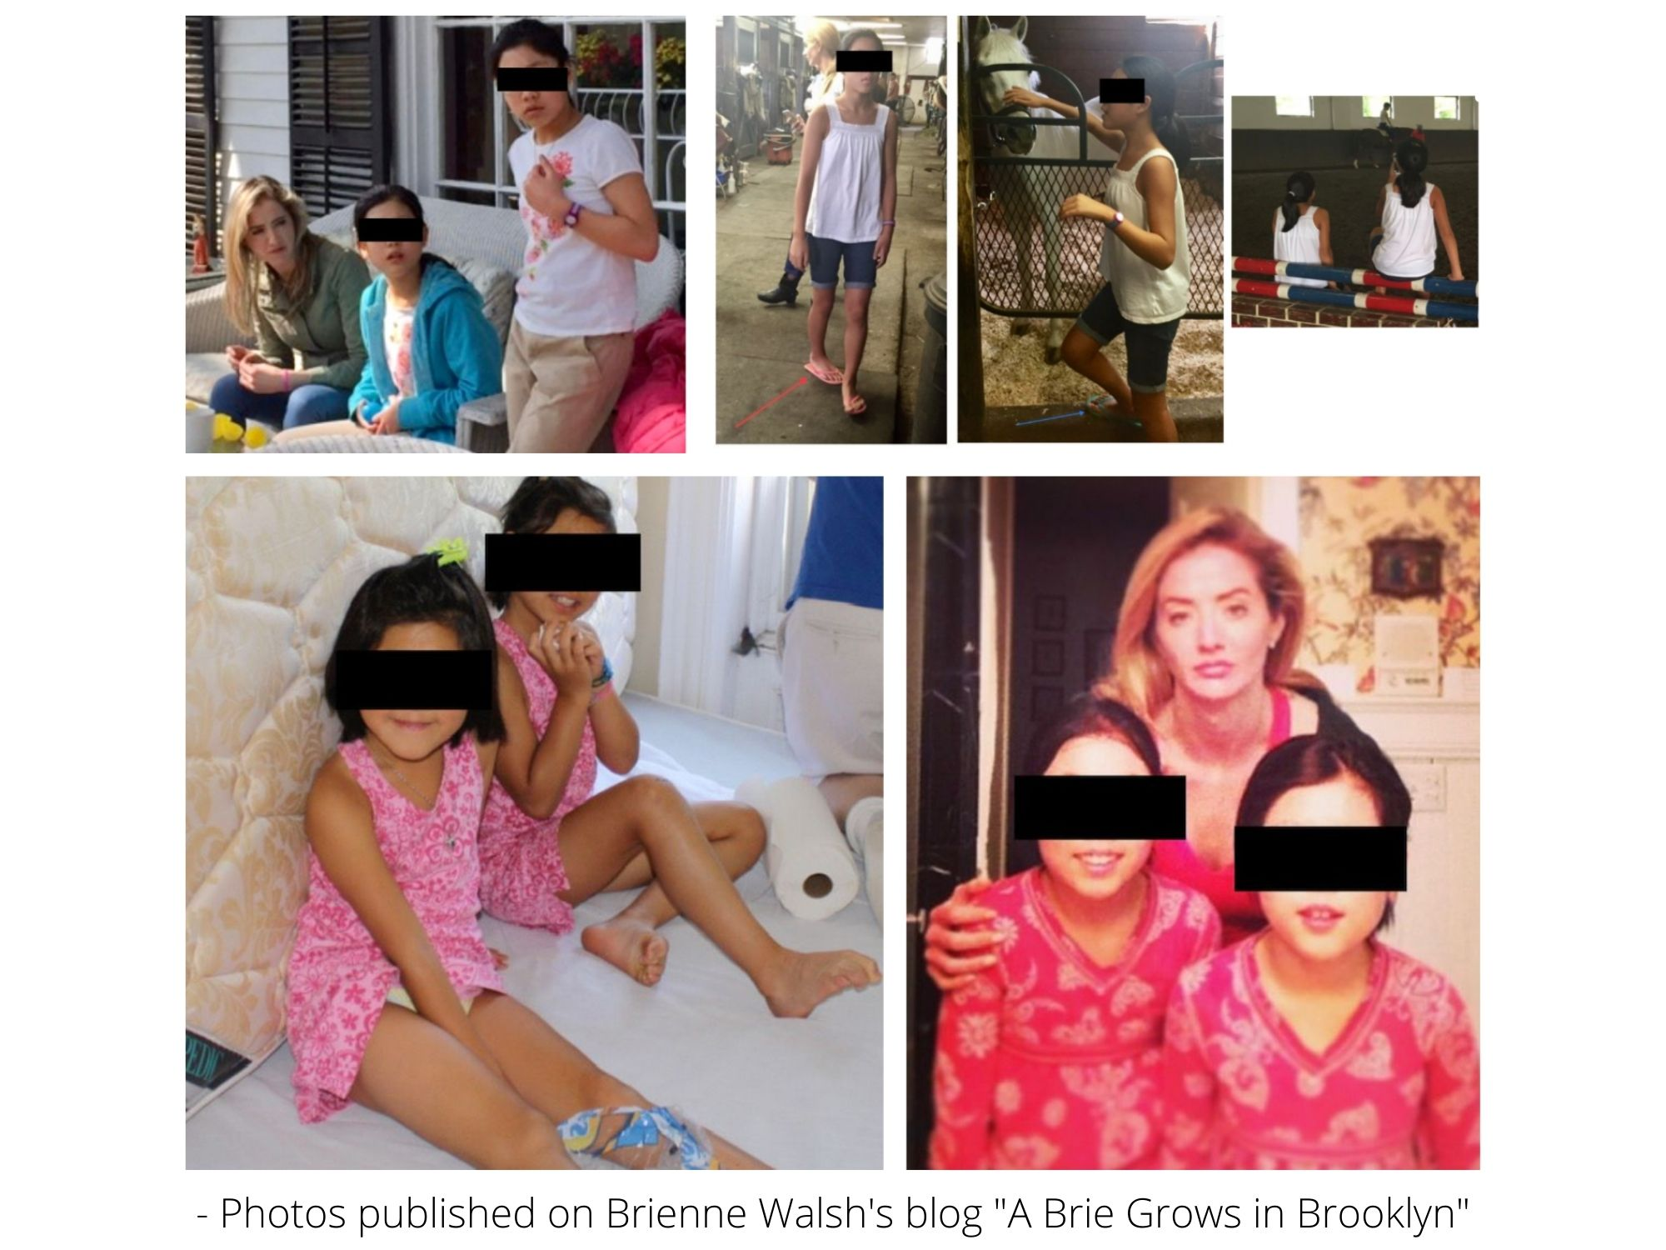

Brienne wrote that “the twins” responded to abuse at their home in much the same way that she and Tara had,

“They are not genetically the same as me, but their reactions to the abuse were identical. One reacts by being super good, and the other reacts by acting out, and they still get punished equally.” (Exhibit 16).

Tara Walsh texted something similar shortly after returning to her childhood estate, “Kiara was having a breakdown – I can’t help but think my Mom gave bpd to 4/6 of us.” (Exhibit 17). In addition to emotional trauma and abuse, she alleges physical abuse as well.

“It’s honestly horrible living here – it's not healthy living here. I feel so sorry for my sisters. And they get into physical fights and stuff with my parents.” (Exhibit 18)

Most shockingly, at least one of the adopted daughters was diagnosed with the same hereditary disorder as the rest of the Walsh children by the ‘family’ Psychiatrist known for diagnosing everyone with Bipolar Disorder. (Exhibit 18) She stopped taking the heavy medication after experiencing negative side effects but later suspected Maura Walsh was ‘slipping’ the Lithium and Seroquel into her food when the negative reactions returned. She reached out to Tara for advice in May 2017. (Exhibit 19).

--------------------------------------------------------

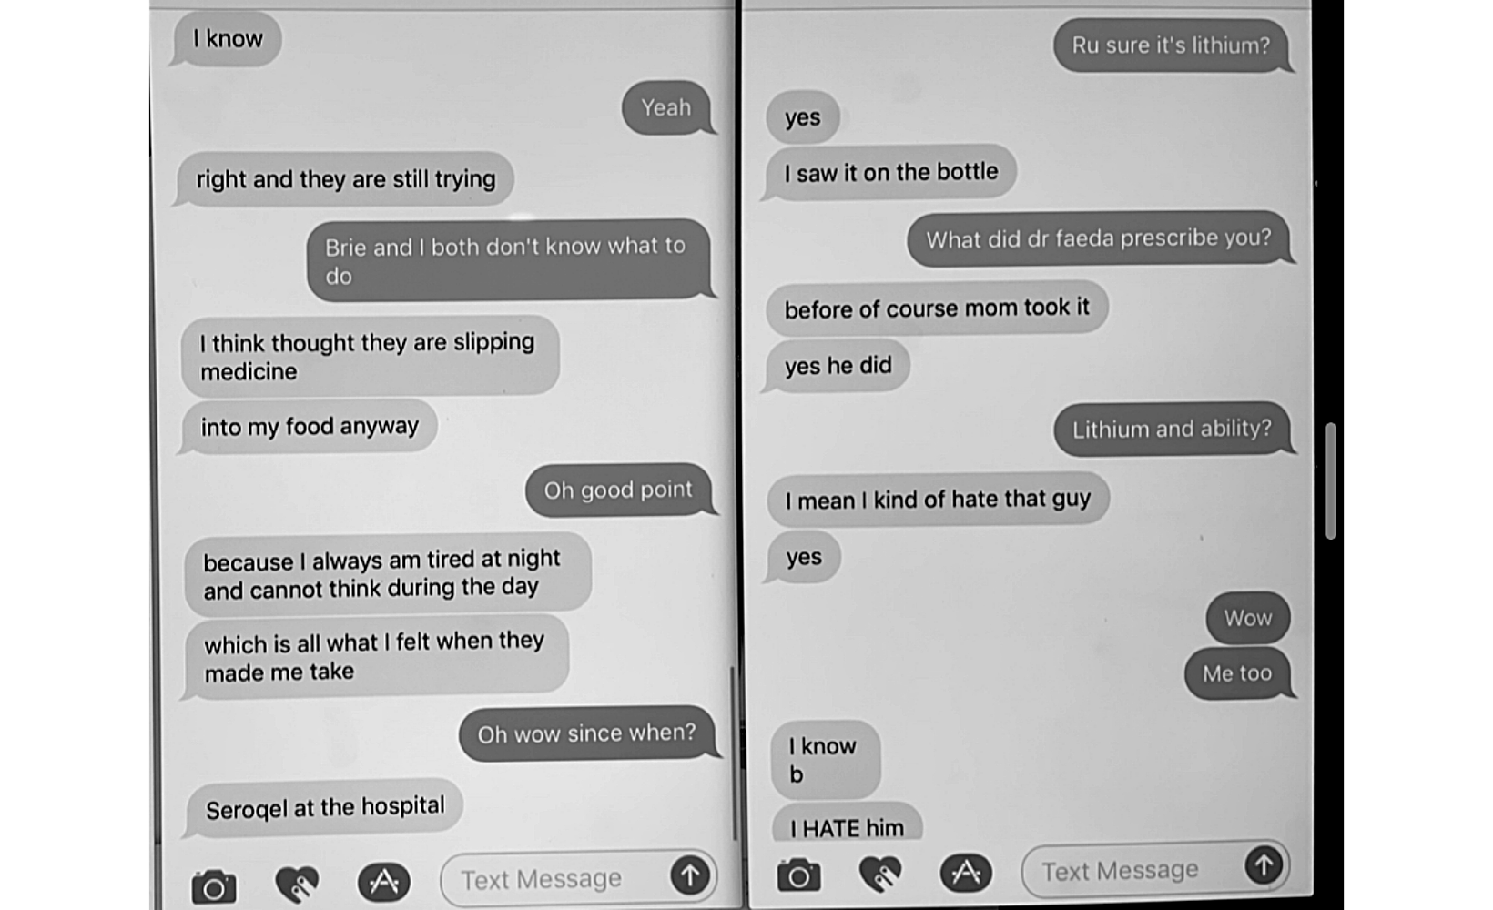

Adopted Daughter: “I think thought they are slipping medicine... into my food anyway... because I always am tired at night and cannot think during the day... which is all what I felt when they made me take it.”

Tara: “Oh wow since when?”

Adopted Daughter: “Seroquel at the hospital” […]

Tara: “Ru sure it’s lithium?”

Adopted Daughter: “Yes... I saw it on the bottle...before of course mom took it”
--------------------------------------------------------

Despite threats from Steve and Maura Walsh, the eldest adopted daughter, Mariah Walsh, recently fled the family home and moved to Savannah, GA to live with Brienne Walsh, her husband, and their two children despite. Brienne writes that a friend of Mariah’s father reached out to her, “saying he was worried about my sister and wondering if she could come and live with us. The same family also offered to help pay for [her] college bills.” (Exhibit 19)

Steve and Maura Walsh were not pleased, “Yesterday [she] told my parents that she was coming to live with me. Their response was that if she does that, she’ll be out on her own. They’ll cut off paying college tuition in the future, as well as her healthcare.” (Exhibit 19)

The Crime: Tara Walsh drugs me in the same manner her mother, Maura Walsh, secretly drugged her siblings.

Maura Walsh would advise her children not to have children, “given the history of mental illness in our family.” (Exhibit 20) For Tara, it was a bit different. They were concerned that her mental illness would cause her to lose custody and endanger the massive family trust. (Exhibit 21). It is likely for these reasons that Tara became fixated on finding and marrying a wealthy man who would ultimately just go away... She could be free of her parents and finally live her life.

In March 2017, after undergoing months of tests while feeling ‘not like myself,’ a toxicology test showed over 6x times the reference range for Lithium – the heavy mood stabilizer that Kiara suspected Maura Walsh was ‘slipping’ into her food. (Exhibit 22). I had never taken nor been prescribed Lithium and the doctors could not explain the results. It was the first time I suspected being drugged.

Over Tara’s subsequent pregnancy and while we lived together in San Francisco, I would repeatedly feel drugged. Emergency room tests did not show anything (Exhibit 23) and doctors were dumbfounded until Evie’s nanny, Abby Tedla, caught Tara ‘slipping’ pills in my wine in May 2018. Tara has since admitted to surreptitiously drugging me with her anti-psychotic medication, Seroquel, in open court (Exhibit 24).

A forensic psychiatrist in San Francisco recommended by Tara’s primary care physician diagnosed her with Borderline Personality Disorder, a diagnosis later confirmed by her long-term therapist. (Exhibit 25) He suspected that Tara would require supervision with Evie for around five years, with intensive treatment, to help with her genetic mental health issues as well as the damage caused by overmedication at a young age and abuse. I was granted Emergency Custody. (Exhibit 26)

Tara rationalized drugging me while testifying at the San Francisco Domestic Restraining Order Hearing by saying, “We were living as a family. I made a family decision.” (Exhibit 26)

It was also clear that I had been targeted due to her perception of my ‘wealth.’ For example, she texted her friend just a week before moving to San Francisco, “I’m better off pretending I want to be with him and getting the most while I can – then leaving him for good... I think he will marry me... Then I can just divorce him for money.” (Exhibit 27). While in San Francisco she used Evie as leverage for marriage (Exhibit 28), then a fake pregnancy (Exhibit 29), and stole my hidden and private financial records to see ‘just how much I had.’ (Exhibit 30)

Tara’s scheme was an open secret in her family. Brienne blogged that Tara was, “scheming to get her baby daddy committed.” (Exhibit 28) Yet also casually discussed with their brother that Tara just wanted money “Yeah she called me last night to say the same thing – [she's] just with Steve to take his money and then she will leave. I get the impression that she is now planning to head back here and is greasing the skid so everyone is happy to see her.” (Exhibit 29)

Steve Walsh Arranges for Kidnapping of Evie

Tara Walsh initially attempted to flee WITHOUT Evie, fearing criminal prosecution but her father talked her into coming back home to San Francisco. (Exhibit 31)

Later she attempted to flee again, but with Evie this time and her father talked her into returning home again to San Francisco. (Exhibit 32)

At this point a Court Order prohibited Tara from leaving California with Evie. (Exhibit 33). Steve Walsh and I had been in regular contact about treatment and (Exhibit 34) he negotiated a ‘two week’ exception from the Court Order so that Evie could accompany Tara on her trip to NY. Tara would get help with her diagnosis and treatment options and Evie wouldn’t leave his sight. (Exhibit 34)

Unbenownst to me, Steve Walsh had already hired a full-time nanny in Westchester, NY even though Tara had an apartment in Brooklyn pre-paid for the next six months and I was in San Francisco. (Exhibit 35). He later admitted in a sworn deposition that he never attempted to abide the court order. (Exhibit 36).

When asked why he didn’t fly to San Francisco considering the severity of the situation he replied, “It’s a six hour flight and that is not something someone just does.” (Exhibit 37) In reality, he understood that Tara wasn’t able to care of Evie on her own and wanted to be Evie’s guardian. Meanwhile, I have spent months in Westchester and flown across the country dozens of times for my daughter.

Since arriving in Westchester Tara has complained of abuse, but been silenced each time.

- “No they love Evie so much – my Mom doesn’t ever want her to leave. But I seriously cannot stand living here... It really hasn’t been that bad – it only gets bad when I say I want to leave” - Tara texts Linda Russell, June 2018 (Exhibit 38)

- “It’s honestly horrible living here – it's not healthy” - Tara texts Steve Russell, June 2018 (Exhibit 39)

- Tara, the court-appointed supervisor, and I all reported suspicious bruises on Evie. (Exhibit 40). When the Walsh’s were asked about it, Tara changed her story and stated the bruises were normal, (Exhibit 41) she followed-up with an odd letter through her attorney stating that there were no bruises and no history of abuse at the Walsh household. Instead claiming that my following-up on the bruises that she, I, and the supervisor noted as suspicious, was harassment of her. (Exhibit 42). Visits were stopped.

My most recent interactions with Tara have shown that she continues to be single-minded about moving out of her parents’ home, showing zero concerns about her or Evie’s safety with me (which is not a surprise but rarely put in writing), but rather a desperation for getting out from under the thumb of her parents whom she was all but estranged from until she fled to their protection after being caught in a crime.

- Emergency Support Motion for funds to move out. (Exhibit 43)
- Trades unlimited access to Evie, in their new home, if he buys Evie a house. (Exhibit 44)

Steve and Maura Walsh Are Instrumental the Alienation of Evie from her Father

Steve and Maura Walsh have been active participants in denying my relationship with my daughter, yet to the court act as if they are not involved.

- This first came to light when I flew to NY to visit Evie based on a verbal agreement between attorneys, Tara’s attorney instructed I reach out to Maura Walsh and
- Steve Walsh at the gate and harasses me, denies any incident to Police, Tara files TOP, SW refuses to testify
- Maura Walsh took Evie to doctor to avoid visit, claimed diarrhea
- Maura Walsh, Evie’s free caregiver during the day, can take Evie to swim, ballet, etc. But refuses to facilitate a visit or facetime with Linda Russell or me. Yet, Tara is receiving ample support for childcare and a third party could facilitate.
- Steve Walsh sends an email to my attorney over HIS thoughts on the visit and the stress reaction. No doctor note. He just KNOWS.

Pattern of Alienation, Neglect, Physical Abuse, Medical Abuse and Unsafe Environment in Chappaqual

- Alienation: Refused to allow access to Evie
- Alienation: Tell Evie her father is sick and dangerous and it is “the Court” that will not let her see him.
- Alienation: Extreme emotional and stressful reactions in front of Evie at pickups and drop offs.
- Alienation: On Jan 27, Evie’s recent birthday father not even allowed to talk on the phone with daughter.
- Alienation: Father, Paternal Grandmother repeatedly denied visits while trials pending in SF and Federal Court.
- Neglect: Unfed, un-napped, unkempt.
- Neglect: Shoes to small, not sent with snacks, car seat, diapers.
- Neglect: At 3.5 not potty trained.
- Neglect: Low agility

Physical & Emotion Abuse:

- Bruises
- Shyness and concern when with Grandparents, totally different personality when Away.
- Signs of Obvious Fear when returning grandparents home.

Medical Child Abuse:

- Evie lives in household with youngest Walsh sibling, who family say justified in secretly medicating by putting Seroquel and Lithium.
- Evidence of diuretics to prevent a visit over two days just prior to the bruises being discovered.
- Deliberately given a food Evie is allergic to in order to prevent future visits:

1) Evie is never provided food for visits.
2) Recent visit she was provided one food to which she was obviously allergic.
3) The allergy is common in Russell family, though Walshes have NEVER asked about family medical history.
4) Evie developed a rash on face and mouth, that paternal grandma treated with Hydrocortisone cream with Mother’s permission and the rash went away very quickly.
5) Evie was returned home without a rash and the food was thrown away.
6) Stephen Walsh began making calls after the visit, however, stating…Evie had “hives” from the stress of the visits. The answer was to not allow any visits going forward. When asked what doctor made that diagnosis, none was provided. No attempt was made to ask Grandma Linda Russell’s opinion. She is in a nurse and will familiar with and shares Evie’s same allergy. Evidence of the allergy can repeatedly be seen in posted family photos and the coincidence of sending her with that food was either deliberate or sign of extreme negligence

Tara’s goal was apparently open secret to her family. Brienne blogged that Tara was, “scheming to get her baby daddy committed.” (Exhibit 28) Yet also casually discussed with their brother that Tara just wanted money “Yeah she called me last night to say the same thing – [she's] just with Steve to take his money and then she will leave. I get the impression that she is now planning to head back here and is greasing the skid so everyone is happy to see her.” (Exhibit 29)

9. Stephen Grant Russell was previously involved in this matter and a custody and other matters in California.

10. A custody or visitation proceeding concerning the same child is pending in New York State.

11. Respondent obtained custody of the child unlawfully and in violation of my rights to due process.

12. It would be in the best interest of the child to have custody and visitation awarded to the Petitioner.

13. An Order of Protection or Temporary Order of Protection was issued against Respondent or against me in the following criminal, matrimonial and/or Family Court proceeding(s) against me in this matter and against Respondent in California.

14. The subject child is not Native American and subject to the Indian Child Welfare Act of 1978 (25 U.S.C. §§ 1901-1963).

15. No previous application has been made to any Court, including a Native-American tribunal, or Judge for the relief herein requested except: this matter and the California matter.

WHEREFORE, the undersigned respectfully prays for an order awarding custody and visitation of the child named herein to the Petitioner and for an Order finding that the Respondent (s) committed various offenses against the Penal Law of this State and for such other relief as to the Court may seem just and proper.

Dated: July 28, 2021

________________________________
Stephen Grant Russell

STATE OF NEW YORK )
ss.:
COUNTY OF WESTCHESTER )

Stephen Grant Russell being duly sworn, says that person is the Petitioner in the above-entitled proceeding and that the foregoing petition is true to own knowledge, except as to matters therein stated to be alleged on information and belief and as to those matters believes it to be true.

________________________________
Stephen Grant Russell

Sworn to before me this 28th day
of July 2021 Via Video.

_________________________________
NOTARY PUBLIC - STATE OF NEW YORK

